Roll: 2007117
Thesis Title: A multi-agent game-theoretic approach for capacitated vehicle routing problem
Alternate Titles:
- A non-cooperative game-theoretic framework for solving the capacitated vehicle routing problem
- Game-theoretic optimization for the capacitated vehicle routing problem under capacity constraints
- A Nash equilibrium-based method for the capacitated vehicle routing problem
- A game-theoretic model for capacity constrained vehicle routing in multi-agent systems
- Solving the capacitated vehicle routing problem using a non-cooperative game-theoretic approach
- A multi-agent equilibrium-based framework for the capacitated vehicle routing problem
- Game-theoretic modeling and optimization of the capacitated vehicle routing problem
1. General Objective: To design a game-theoretic multi-agent approach for optimizing routes in the capacitated vehicle routing problem under capacity constraints.
2. Specific Objectives:
- To model the CVRP as a multi-agent game.
- To represent each vehicle as an independent agent in the routing process.
- To develop a non-cooperative game-theoretic approach for route optimization.
- To find efficient routing solutions using Nash equilibrium.
3. Research Questions:
- How can a multi-agent non-cooperative game be formulated for the capacitated vehicle routing problem?
- To what extent can game-theoretic decision-making improve routing efficiency under vehicle capacity constraints?
- How can Nash equilibrium concepts be used to derive stable solutions for the CVRP?
- How effective is the proposed framework compared with conventional optimization and heuristic methods?
- How robust and scalable is the proposed approach for benchmark CVRP instances?
4. Research Framework:
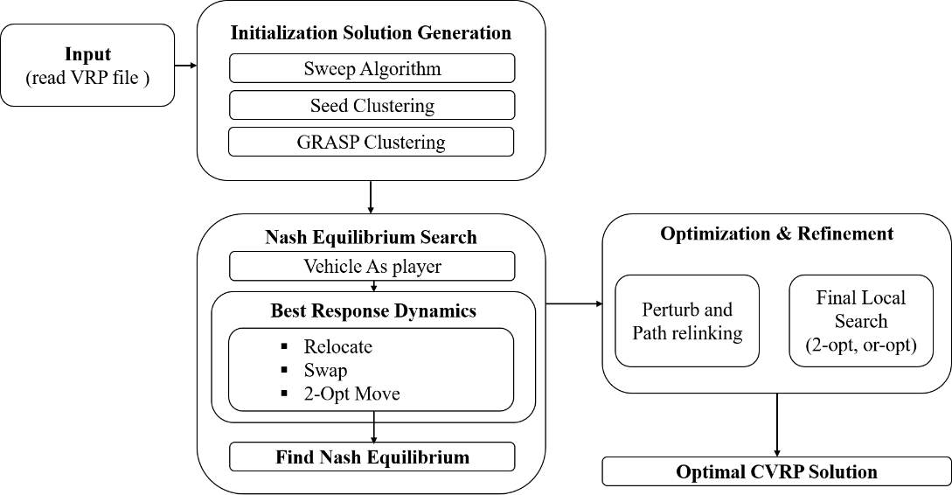
Figure 1: Framework game-theoretic approach for CVRP
Compared with Vidal’s HGS-CVRP, the proposed method uses a different approach. While HGS-CVRP is a population-based hybrid genetic search combining binary tournament selection, ordered crossover, Split decoding, local search, adaptive penalties, and diversity controlled survivor selection, the proposed approach follows a game-theoretic route centric framework in which vehicles act as players and solution updates are produced through best-response dynamics until a Nash equilibrium is reached. Moreover, unlike HGS-CVRP, which relies on random initialization and a specialized Swap* neighborhood for intensification, the proposed method uses diversified constructive initialization through Sweep, seed clustering, and GRASP, followed by perturbation, path relinking, and final 2-opt/or-opt refinement. Therefore, the proposed framework may be viewed as a construct, stabilize, perturb, refine methodology, whereas the base paper represents a select, recombine, educate, survive evolutionary framework.

5. Significance of the Proposed Method:
- The proposed method offers a different and more intuitive search strategy compared with common state-of-the-art CVRP methods, which are mostly based on genetic or hybrid metaheuristic frameworks.
- It combines good initial solution generation, route improvement, and final refinement in a simple and structured way, while state-of-the-art methods often rely on more complex population management and advanced neighborhood search.
- Its main significance is not only in solution quality, but also in its simplicity, interpretability, and flexibility when compared with strong methods such as HGS-CVRP.
References:
[1] | T. Vidal, “Hybrid genetic search for the CVRP: Open-source implementation and SWAP* neighborhood,” Computers & Operations Research, vol. 140, p. 105643, 2022, doi: 10.1016/j.cor.2021.105643.
[2] | V. Fischer, M. Pacheco Paneque, A. Legrain, and R. Bürgy, “A capacitated multi-vehicle covering tour problem on a road network and its application to waste collection,” European Journal of Operational Research, vol. 315, no. 1, pp. 338–353, 2024, doi: 10.1016/j.ejor.2023.11.040.

Plan to Complete the Thesis Work and Publication (If):
Step 1: Modify the framework into a publishable form and implement most of the methodology by April.
Step 2: Complete the remaining work and finish the thesis report by 25 June.
Step 3: Prepare the publication manuscript and make it submission ready by July.

